University Of Kalyani

Dr. Bimalendu Biswas

M.Com., DITA, MBA, Ph.D

Controller of Examinations

Kalyani 741 235 West Bengal

Phone Office: 033-2580-8364

9748048314/8167849442(M)

Email:controllerofexaminationsku@gmail.com

No. COE/10/2020-21 Date: 20.08.2021

CIRCULAR

This is for information of all concerned that the link to the portal for examination form fill up of U.G. 4th Semester Honours and Programme Courses Examinations, 2021 is mentioned below. The portal will be opened on 23.08.2021 (4.00 p.m. onwards) and closed on 11.09.2021 (5 p.m. onwards). The candidates may collect their ADMIT CARD by downloading and printing it from on-line system instantly, at the time of submission of examination form.
The college authorities are earnestly requested to make an arrangement for collecting the examination fees of this semester as early as possible.

All are requested to take note of it and act accordingly.

URL For 4th semester candidates | https://pcdpcal.com/ku-sem4-2021/

Sd./-
Controller of Examinations

Copy forwarded to :
- The Hon’ble Vice Chancellor, K.U.- for kind information only.
- The Hon’ble Pro-Vice Chancellor, K.U.- for kind information only.
- The Registrar, K.U.
- The Finance Officer, K.U.
- The Principals / TICs / OICs of all affiliated General Degree Colleges under K.U.
- The Confidential Press.

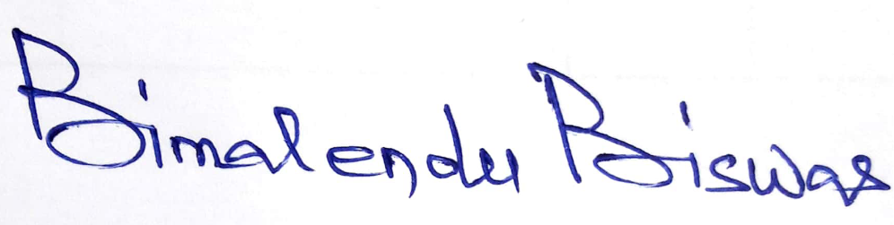
Controller of Examinations

