UNIVERSITY OF KALYANI
REVISED PROGRAMME FOR HONOURS, MAJOR AND GENERAL CANDIDATES (GENERAL THEORITICAL PAPERS)
PART-II EXAMINATION, 2021
BLENDED MODE

GENERAL THEORITICAL PAPERS

TIME | FULL PAPER | HALF PAPER
1ST HALF | 10 a.m. to 1 p.m | 10 a.m. to 12 noon
2ND HALF | 2 p.m. to 5 p.m | 2 p.m. to 4 p.m

REVISED DATE | 1ST HALF PAPER II | 2ND HALF PAPER III
06.10.2021(WEDNESDAY) | PHYSICS, ZOOLOGY, EDUCATION &  FILM STUDIES | EDUCATION &  FILM STUDIES

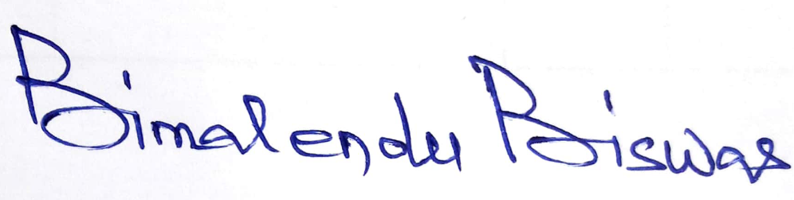
Date: 25.09.2021 Controller of Examinations

